Table S1 . Mg isotope compositions and external precisions of standards and test solutions passed through ion-exchange chromatography.

Sample | δ²⁶Mg | 2σ | δ²⁵Mg | 2σ | N
Isotope standards in this study
Cambridge 1 | -2.59 | 0.07 | -1.33 | 0.03 | 9
DSM3 | 0 | 0.08 | 0.01 | 0.04 | 9
Test solutions processed by the ion-exchange procedure
IAPSO seawater | -0.77 | 0.04 | -0.4 | 0.02 | 4
BHVO-2 | -0.33 | 0.08 | -0.18 | 0.04 | 4
DST-2 | -0.26 | 0.04 | -0.12 | 0.01 | 2
BIR | -0.26 | 0.13 | -0.15 | 0.08 | 2
Isotope compositions of standards in references
HPS909104 (Li et al., 2012) | -0.67 | 0.13 | -0.34 | 0.08 | 48
Cambridge 1 (Hippler et al., 2009) | -2.58 | 0.04 | -1.34 | 0.02 | 56
Cambridge 1 (Li et al., 2012) | -2.57 | 0.12 | -1.33 | 0.1 | 87
Cambridge 1 (Chopra et al., 2012) | -2.6 | 0.15 | -1.34 | 0.09 | 576
Cambridge 1 (An et al., 2014) | -2.597 | 0.042 | -1.343 | 0.036 | 49
Cambridge 1 (Teng et al., 2015) | -2.623 | 0.03 | -1.358 | 0.03 | ﹥20
DSM3 (Tipper et al., 2010) | 0 | 0.05 | 0 | 0.03 | 100
DSM3 (Li et al., 2012) | 0.02 | 0.13 | 0 | 0.09 | 109
IAPSO seawater (Hippler et al., 2009) | -0.8 | 0.05 | -0.42 | 0.02 | 10
BHVO-2 (Huang et al., 2012) | -0.24 | 0.08 | -0.12 | 0.05 | ﹥20
BHVO-2 (Pogge von Strandmann et al., 2011) | -0.26 | 0.06 | -0.14 | 0.04 | 4
BIR (Shen et al., 2013) | -0.30 | 0.04 | -0.16 | 0.03 | 3
DST-2(Bizzaro et al., 2011) | -0.23 | 0.03 | -0.12 | 0.02 | 7
DST-2(Teng et al., 2010) | -0.31 | 0.05 | -0.16 | 0.04 | 7
DST-2(Teng et al., 2015) | -0.32 | 0.06 | -0.17 | 0.04 | ﹥20
Reference:
An Y., Wu F., Xiang Y., Nan X., Yu X., Yang J., Yu H., Xie L. and Huang F. (2014) High-precision Mg isotope analyses of low-Mg rocks by MC-ICP-MS. Chem. Geol. 390, 9-21.
Bizzarro M., Paton C., Larsen K., Schiller M., Trinquier A. and Ulfbeck D. (2011) High-precision Mg-isotope measurements of terrestrial and extraterrestrial material by HR-MC-ICPMS—implications for the relative and absolute Mg-isotope composition of the bulk silicate Earth. J. Anal. At. Spectrom. 26, 565-577.
Chopra R., Richter F. M., Bruce Watson E. and Scullard C. R. (2012) Magnesium isotope fractionation by chemical diffusion in natural settings and in laboratory analogues. Geochim. Cosmochim. Acta 88, 1-18.
Hippler D., Buhl D., Witbaard R., Richter D. K. and Immenhauser A. (2009) Towards a better understanding of magnesium-isotope ratios from marine skeletal carbonates. Geochim. Cosmochim. Acta 73, 6134-6146.
Huang K.-J., Shen B., Lang X.-G., Tang W.-B., Peng Y., Ke S., Kaufman A. J., Mao H.-R. and Li F.-B. (2015) Magnesium isotopic compositions of the Mesoproterozoic dolostones: Implications for Mg isotopic systematics of marine carbonates. Geochim. Cosmochim. Acta 164, 333-351.
Li W., Chakraborty S., Beard B. L., Romanek C. S. and Johnson C. M. (2012) Magnesium isotope fractionation during precipitation of inorganic calcite under laboratory conditions. Earth Planet. Sci. Lett. 333-334, 304-316.
Pogge von Strandmann P. A. E., Elliott T., Marschall H. R., Coath C., Lai Y.-J., Jeffcoate A. B. and Ionov D. A. (2011) Variations of Li and Mg isotope ratios in bulk chondrites and mantle xenoliths. Geochim. Cosmochim. Acta 75, 5247-5268.
Shen B., Wimpenny J., Lee C.-T. A., Tollstrup D. and Yin Q.-Z., 2013. Magnesium isotope systematics of endoskarns: Implications for wallrock reaction in magma chambers. Chem. Geol. 356, 209-214.
Teng F.-Z., Li W.-Y., Ke S., Marty B., Dauphas N., Wu F.-Y. and Pourmand A. (2010) Magnesium isotopic composition of the Earth and chondrites. Geochim. Cosmochim. Acta 74, 4150-4166.
Tipper E. T., Gaillardet J., Louvat P., Capmas F. and White A. F. (2010) Mg isotope constraints on soil pore-fluid chemistry: Evidence from Santa Cruz, California. Geochim. Cosmochim. Acta 74, 3883-3896.
Teng F.-Z., Li W.-Y., Ke S., Yang W., Liu S.-A., Sedaghatpour F., Wang S.-J., Huang K.-J., Hu Y., Ling M.-X., Xiao Y., Liu X.-M., Li X.-W., Gu H.-O., Sio C. K., Wallace D. A., Su B.-X., Zhao L., Chamberlin J., Harrington M. and Brewer A. (2015) Magnesium Isotopic Compositions of International Geological Reference Materials. Geostand. Geoanal. Res. 39, 329-339.

Table S2. XRD analyses of mineralogical parameters, including d₁₀₄ (Å), dolomite degree of order (R) and mole percent of MgCO₃ in mineral

Sample number | Depth/m | XRD analysis
Sample number | Depth/m | Calcite |  | Dolomite
Sample number | Depth/m | d₁₀₄(Å) | MgCO₃ mole% | d₁₀₄(Å) | MgCO₃ mole% | I(015)I(110)
ZC-1 | 65.38 | 3.029 | 1.17 | 2.886 | 50 | 0.34
ZC-2 | 64.18 | 3.029 | 1.17 | / | / | /
ZC-3 | 61.88 | 3.029 | 1.17 | 2.886 | 50 | 0.39
ZC-4 | 60.38 | 3.029 | 1.17 | 2.886 | 50 | /
ZC-5 | 58.88 | 3.029 | 1.17 | 2.886 | 50 | 0.42
ZC-6 | 56.88 | 3.029 | 1.17 | / | / | /
ZC-7 | 55.88 | 3.029 | 1.17 | 2.886 | 50 | 0.4
ZC-8 | 52.88 | 3.029 | 1.17 | 2.886 | 50 | 0.36
ZC-9 | 50.38 | 3.029 | 1.17 | 2.886 | 50 | /
ZC-10 | 46.18 | 3.029 | 1.17 | 2.886 | 50 | 0.35
ZC-11 | 42.28 | 3.028 | 1.18 | 2.885 | 49.8 | 0.34
ZC-12 | 38.68 | 3.028 | 1.18 | 2.885 | 49.8 | 0.34
ZC-13 | 35.68 | 3.029 | 1.17 | 2.886 | 50 | /
ZC-14 | 29.13 | 3.029 | 1.17 | / | / | /
ZC-15 | 27.78 | 3.029 | 1.17 | 2.886 | 50
ZC-16 | 24.28 | 3.029 | 1.17 | 2.886 | 50 | 0.41
ZC-17 | 22.15 | 3.029 | 1.17 | / | / | /
ZC-18 | 19.18 | 3.031 | 1.16 | 2.886 | 50 | 0.39
ZC-19 | 16.88 | 3.029 | 1.17 | 2.884 | 49.5 | /
ZC-20 | 11.88 | 3.029 | 1.17 | 2.886 | 50 | 0.43
ZC-21 | 10.78 | 3.029 | 1.17 | 2.882 | 49.2 | /
ZC-22 | 6.88 | 3.029 | 1.17 | 2.882 | 49.2 | 0.51
ZC-23 | 4.58 | 3.032 | 1.15 | 2.882 | 49.2 | 0.35
ZC-24 | 63.05 | 3.029 | 1.17 | 2.886 | 50 | 0.38
ZC-25 | 62.17 | 3.029 | 1.17 | / | / | /
ZC-26 | 37.25 | 3.029 | 1.17 | / | / | /
ZC-27 | 26 | 3.029 | 1.17 | / | / | /
ZC-28 | 17.9 | 3.029 | 1.17 | 2.886 | 50 | 0.39
ZC-29 | 11.3 | 3.029 | 1.17 | 2.883 | 49.3 | 0.36
ZC-30 | 11.5 | 3.029 | 1.17 | 2.886 | 50 | 0.46
ZC-31 | 10 | 3.029 | 1.17 | 2.885 | 49.8 | 0.44
ZC-32 | 8 | 3.031 | 1.16 | 2.882 | 48.2 | 0.46
ZC-33 | 5 | 3.032 | 1.16 | 2.886 | 50 | 0.38
ZC-34 | 4.1 | 3.029 | 1.17 | 2.886 | 50 | 0.41
ZC-35 | 3.5 | 3.029 | 1.17 | 2.883 | 49.3 | 0.46

Table S3. Major and trace element contents of carbonates

Sample number | Depth/m | Element content
Sample number | Depth/m | Ca/ppm | Mg/ppm | Fe/ppm | Al/ppm | Sr/ppm | Mn/ppm
ZC-1 | 65.38 | 263889 | 90493 | 3668 | 5082 | 147 | 70
ZC-2 | 64.18 | 388184 | 2842 | 2439 | 3458 | 3471 | 25
ZC-3 | 61.88 | 281340 | 74528 | 1930 | 3069 | 159 | 58
ZC-4 | 60.38 | 358199 | 23823 | 1608 | 2137 | 632 | 40
ZC-5 | 58.88 | 248824 | 100144 | 3239 | 2827 | 118 | 79
ZC-6 | 56.88 | 383066 | 5237 | 1196 | 3238 | 2055 | 18
ZC-7 | 55.88 | 259677 | 83590 | 3606 | 6703 | 151 | 73
ZC-8 | 52.88 | 307629 | 58269 | 1587 | 2836 | 329 | 36
ZC-9 | 50.38 | 374991 | 15477 | 955 | 1979 | 284 | 28
ZC-10 | 46.18 | 376825 | 10824 | 1099 | 2234 | 695 | 33
ZC-11 | 42.28 | 339955 | 39606 | 862 | 1978 | 216 | 24
ZC-12 | 38.68 | 344774 | 35893 | 830 | 2255 | 211 | 27
ZC-13 | 35.68 | 358792 | 25533 | 736 | 2044 | 247 | 31
ZC-14 | 29.13 | 385556 | 3596 | 733 | 1949 | 1291 | 26
ZC-15 | 27.78 | 316173 | 48471 | 1787 | 3530 | 269 | 39
ZC-16 | 24.28 | 278651 | 84518 | 1081 | 2112 | 153 | 42
ZC-17 | 22.15 | 390876 | 3418 | 618 | 1624 | 2173 | 20
ZC-18 | 19.18 | 247693 | 106491 | 1044 | 1684 | 148 | 53
ZC-19 | 16.88 | 364616 | 25294 | 551 | 1025 | 204 | 27
ZC-20 | 11.88 | 287358 | 78239 | 858 | 1828 | 179 | 45
ZC-21 | 10.78 | 361559 | 26370 | 549 | 1257 | 577 | 18
ZC-22 | 6.88 | 337030 | 45485 | 510 | 1007 | 149 | 40
ZC-23 | 4.58 | 296099 | 72946 | 706 | 900 | 135 | 110
ZC-24 | 63.05 | 264760 | 87239 | 2027 | 2867 | 199 | 154
ZC-25 | 62.17 | 389701 | 3797 | 905 | 1409 | 3325 | 52
ZC-26 | 37.25 | 388746 | 3035 | 688 | 1533 | 2423 | 25
ZC-27 | 26 | 366563 | 20622 | 487 | 1273 | 291 | 39
ZC-28 | 17.9 | 296010 | 72075 | 857 | 2063 | 262 | 45
ZC-29 | 11.3 | 355156 | 29634 | 615 | 1266 | 239 | 42
ZC-30 | 11.5 | 253877 | 99908 | 934 | 1264 | 162 | 78
ZC-31 | 10 | 366523 | 22021 | 498 | 1147 | 267 | 40
ZC-32 | 8 | 295440 | 71687 | 547 | 925 | 161 | 59
ZC-33 | 5 | 359962 | 29266 | 497 | 1003 | 219 | 57
ZC-34 | 4.1 | 250498 | 106552 | 700 | 813 | 108 | 129
ZC-35 | 3.5 | 245527 | 103614 | 833 | 1945 | 230 | 133

Table S4 The relative proportion of dolomite and calcite calculated by the measured Mg and Ca concentrations and XRD data respectively
.
Sample number | Depth/m | Mineral component based on major element content |  | Mineral component based on XRD
Sample number | Depth/m | Dolomite/wt, % | Calcite/wt, % | Dolomite/wt, % | Calcite/wt, %
ZC-1 | 65.38 | 70.19 | 29.81 | 68.89 | 31.11
ZC-2 | 64.18 | 0.06 | 99.94 | 0 | 100
ZC-3 | 61.88 | 58.16 | 41.84 | 61.01 | 38.99
ZC-4 | 60.38 | 16.79 | 83.21 | 13.57 | 86.43
ZC-5 | 58.88 | 78.25 | 21.75 | 74.16 | 25.84
ZC-6 | 56.88 | 1.98 | 98.02 | 0 | 100
ZC-7 | 55.88 | 67.13 | 32.87 | 69.78 | 30.22
ZC-8 | 52.88 | 44.55 | 55.45 | 47.62 | 52.38
ZC-9 | 50.38 | 9.97 | 90.03 | 12.93 | 87.07
ZC-10 | 46.18 | 6.41 | 93.59 | 3.77 | 96.23
ZC-11 | 42.28 | 29.07 | 70.93 | 27.2 | 72.8
ZC-12 | 38.68 | 26.16 | 73.84 | 27.06 | 72.94
ZC-13 | 35.68 | 18 | 82 | 13.61 | 86.39
ZC-14 | 29.13 | 0.67 | 99.33 | 0 | 100
ZC-15 | 27.78 | 37.21 | 62.79 | 40.37 | 59.63
ZC-16 | 24.28 | 64.32 | 35.68 | 66.98 | 33.02
ZC-17 | 22.15 | 0.49 | 99.51 | 0 | 100
ZC-18 | 19.18 | 81.68 | 18.32 | 80.24 | 19.76
ZC-19 | 16.88 | 17.53 | 82.47 | 19.7 | 80.3
ZC-20 | 11.88 | 59.38 | 40.62 | 62.16 | 37.84
ZC-21 | 10.78 | 18.45 | 81.55 | 18.89 | 81.11
ZC-22 | 6.88 | 33.24 | 66.76 | 35.9 | 64.1
ZC-23 | 4.58 | 55.02 | 44.98 | 54.51 | 45.49
ZC-24 | 63.05 | 68.25 | 31.75 | 70.42 | 29.58
ZC-25 | 62.17 | 0.8 | 99.2 | 0 | 100
ZC-26 | 37.25 | 0.21 | 99.79 | 0 | 100
ZC-27 | 26 | 14.07 | 85.93 | 9.25 | 90.75
ZC-28 | 17.9 | 54.52 | 45.48 | 51.97 | 48.03
ZC-29 | 11.3 | 21.12 | 78.88 | 27.52 | 72.48
ZC-30 | 11.5 | 77.09 | 22.91 | 78.77 | 21.23
ZC-31 | 10 | 15.09 | 84.91 | 18.33 | 81.67
ZC-32 | 8 | 54.37 | 45.63 | 52.39 | 47.61
ZC-33 | 5 | 20.58 | 79.42 | 26.66 | 73.34
ZC-34 | 4.1 | 81.12 | 18.88 | 84 | 16
ZC-35 | 3.5 | 80.71 | 19.29 | 74.23 | 25.77

Table S5. C, O, Sr and Mg isotope data of the samples.

Sample number | Depth/m | Isotope composition
Sample number | Depth/m | δ¹³C_{V-PDB} | δ¹⁸O_{V}-_{PDB} | ⁸⁷Sr/⁸⁶Sr | 2SE | δ²⁶Mg(‰) | 2SD | δ²⁵Mg(‰) | 2SD | N
ZC-1 | 65.38 | 5.2 | -6.6 | 0.708365 | 0.000014 | -1.55 | 0.05 | -0.8 | 0 | 2
ZC-2 | 64.18 | 5.4 | -6.6 | 0.708024 | 0.00001 | -2.28 | 0.15 | -1.18 | 0.11 | 2
ZC-3 | 61.88 | 4.5 | -7.5 | 0.708125 | 0.000013 | -1.66 | 0.05 | -0.87 | 0.03 | 2
ZC-4 | 60.38 | 4.2 | -8.6 | 0.708104 | 0.000012 | -1.67 | 0.03 | -0.87 | 0.03 | 2
ZC-5 | 58.88 | 4.7 | -7.8 | 0.708226 | 0.000015 | -1.48 | 0.08 | -0.76 | 0.06 | 2
ZC-6 | 56.88 | 5.2 | -7.1 | 0.708015 | 0.000009 | -1.85 | 0.08 | -0.96 | 0.05 | 2
ZC-7 | 55.88 | 5.3 | -8.2 | 0.708301 | 0.000011 | -1.46 | 0.1 | -0.75 | 0.05 | 2
ZC-8 | 52.88 | 5.9 | -6.5 | 0.708133 | 0.000013 | -1.53 | 0.03 | -0.79 | 0.02 | 2
ZC-9 | 50.38 | 5.5 | -7.3 | 0.708061 | 0.000013 | -1.75 | 0.12 | -0.91 | 0.04 | 2
ZC-10 | 46.18 | 5.1 | -7.9 | 0.708038 | 0.000008 | -1.8 | 0.02 | -0.94 | 0.02 | 2
ZC-11 | 42.28 | 6.4 | -6.7 | 0.708048 | 0.000011 | -1.51 | 0.11 | -0.78 | 0.06 | 2
ZC-12 | 38.68 | 6.4 | -7.1 | 0.708065 | 0.00001 | -1.51 | 0.03 | -0.78 | 0.04 | 2
ZC-13 | 35.68 | 6.0 | -7.4 | 0.70809 | 0.00001 | -1.68 | 0.01 | -0.86 | 0.04 | 2
ZC-14 | 29.13 | 6.1 | -6.9 | 0.70802 | 0.000011 | -2.14 | 0.07 | -1.11 | 0.03 | 2
ZC-15 | 27.78 | 4.4 | -10.4 | 0.70811 | 0.000014 | -1.56 | 0.14 | -0.8 | 0.09 | 2
ZC-16 | 24.28 | 5.1 | -9.1 | 0.70818 | 0.000013 | -1.49 | 0.03 | -0.77 | 0.01 | 2
ZC-17 | 22.15 | 6.5 | -7.5 | 0.70801 | 0.000013 | -2.01 | 0.08 | -1.05 | 0.04 | 2
ZC-18 | 19.18 | 4.4 | -9.8 | 0.708146 | 0.000014 | -1.51 | 0.01 | -0.78 | 0.01 | 2
ZC-19 | 16.88 | 5.3 | -8.5 | 0.708055 | 0.00001 | -1.58 | 0.06 | -0.81 | 0.02 | 2
ZC-20 | 11.88 | 4.4 | -8.6 | 0.708056 | 0.000015 | -1.55 | 0.08 | -0.8 | 0.03 | 2
ZC-21 | 10.78 | 6.6 | -8.0 | 0.708042 | 0.000013 | -1.49 | 0.04 | -0.78 | 0.01 | 2
ZC-22 | 6.88 | 6.5 | -7.9 | 0.708107 | 0.000015 | -1.49 | 0.04 | -0.78 | 0.01 | 2
ZC-23 | 4.58 | 5.0 | -9.3 | 0.70818 | 0.000013 | -1.48 | 0.05 | -0.78 | 0.03 | 2
ZC-24 | 63.05 | 4.8 | -7.8 | 0.708163 | 0.000012 | -1.59 | 0.05 | -0.82 | 0.05 | 2
ZC-25 | 62.17 | 5.0 | -7.5 | 0.708026 | 0.000009 | -1.91 | 0.11 | -0.99 | 0.07 | 2
ZC-26 | 37.25 | 6.2 | -6.6 | 0.708018 | 0.00001 | -2.26 | 0.11 | -1.18 | 0.05 | 2
ZC-27 | 26 | 6.4 | -7.8 | 0.708072 | 0.000012 | -1.68 | 0.07 | -0.87 | 0.01 | 2
ZC-28 | 17.9 | 6.1 | -7.8 | 0.708156 | 0.000014 | -1.57 | 0.05 | -0.82 | 0 | 2
ZC-29 | 11.3 | 6.3 | -8.3 | 0.708116 | 0.000019 | -1.51 | 0.03 | -0.78 | 0.01 | 2
ZC-30 | 11.5 | 4.5 | -9.5 | 0.708146 | 0.000015 | -1.52 | 0.01 | -0.79 | 0.03 | 2
ZC-31 | 10 | 4.4 | -9.4 | 0.70809 | 0.000013 | -1.66 | 0.05 | -0.86 | 0.02 | 2
ZC-32 | 8 | 5.9 | -8.7 | 0.708157 | 0.00001 | -1.43 | 0.07 | -0.74 | 0.06 | 2
ZC-33 | 5 | 5.9 | -8.7 | 0.708118 | 0.000013 | -1.6 | 0.06 | -0.83 | 0.01 | 2
ZC-34 | 4.1 | 4.3 | -9.7 | 0.708276 | 0.000016 | -1.53 | 0.01 | -0.79 | 0.02 | 2
ZC-35 | 3.5 | 4.4 | -9.9 | 0.708322 | 0.000012 | -1.51 | 0 | -0.78 | 0.03 | 2

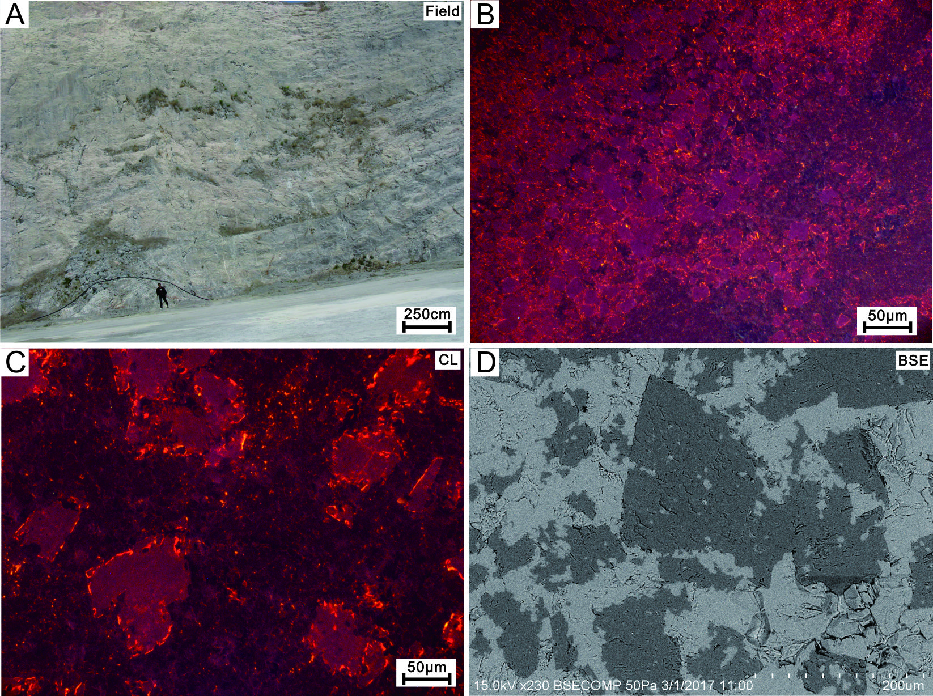
Figure S1. Photographs showing the petrographic characteristics of Zhoucunchong Formation in Geshan section. (A) The full view of Geshan outcrop; (B) Cathodoluminescence photomicrograph of limy dolostone (ZC-28); (C) Cathodoluminescence photomicrograph of dissolution texture of dolomite (ZC-8); (D) Back scattering image of dissolution texture of dolomite (ZC-26).

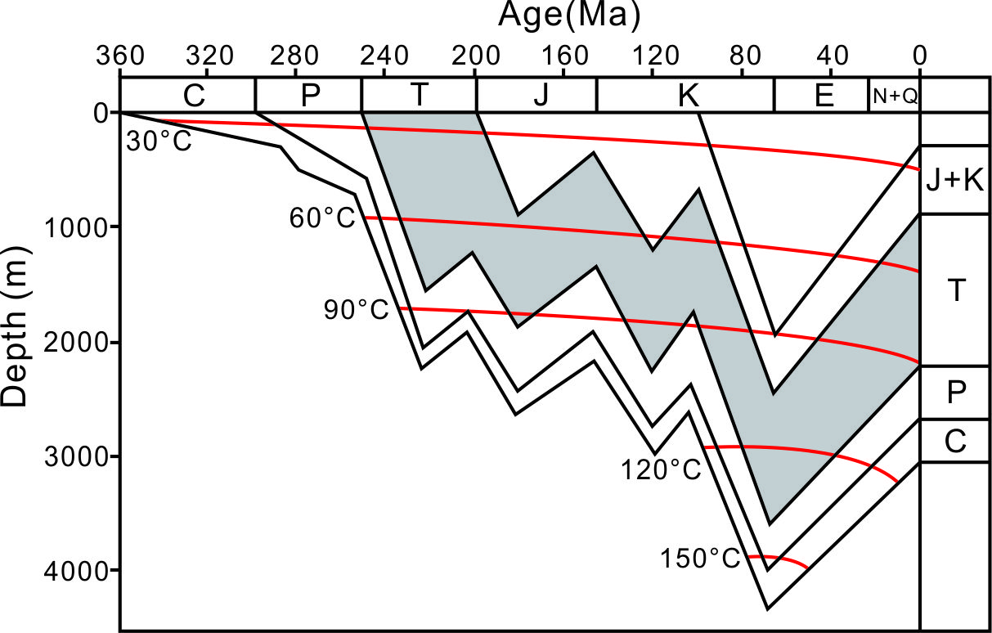
Figure S2. The burial history of the Lower Yangtze Block, after Hua (2014) and Huang et al. (2014).

